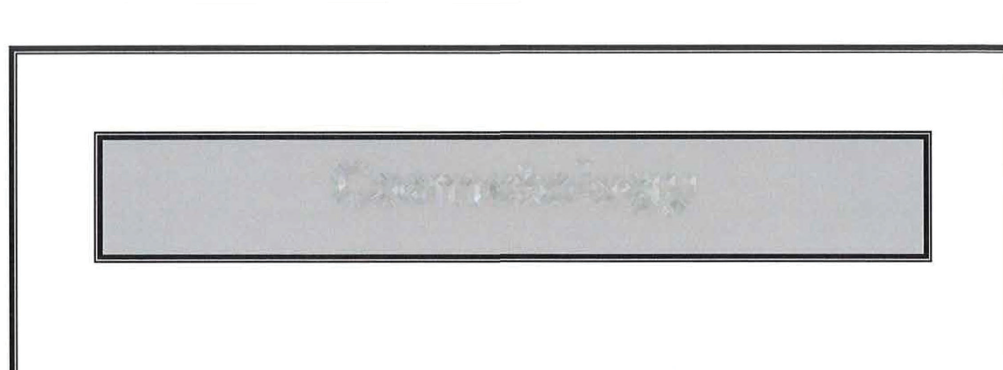
Cosmetology

District 8 Competition
Monday, January 15,2023

Students must follow hosting schools Covid 19 protocols

SkillsUSA
Cosmetology Contest

Purpose:
To evaluate each contestant’s preparation for employment and to recognize outstanding students for excellence and professionalism in the field of cosmetology.

Contestants will demonstrate their skills in trend haircutting, hair styling and long formal hair design in four separate tests. All work is performed on mannequins so everyone begins with the same model and same type of hair. Contestants will recreate one woman’s and one man’s trend haircut and style from a finished photo. Students display creativity in the long formal hair segment of the competition where these future salon professionals demonstrate their own design skills.

Clothing Requirements:
For men: Official SkillsUSA white dress shirt, black dress slacks, black socks and black leather work or dress shoes. Optional: style smock or apron to protect clothing with no school, name or manufacturer identification.

For women: Official white top, black dress slacks, black socks or black or skin-tone hose, and black leather, work or dress shoes. Optional: Industry style smock or apron to protect clothing with no school, name or manufacturer identification.

Eligibility
Open to active SkillsUSA members enrolled in career and technical programs with cosmetology as the occupational objective.

Equipment and Materials:
- Supplied by host:
  - Stations with mirrors, styling chairs, and electrical outlets
  - Paper towels
  - All pictures or literature of styles, haircuts and technical
  - First aid kit
  - Access to water
  - Sanex strips
- Supplied by the contestant:
  - Cutting shears
  - Thinning shears
  - Razor and spare blade
  - Clipper
  - Thermal tools (flat iron and/or curling iron)
  - Blow dryer
  - Styling products of choice (products must be labeled)
  - Bobbie pins, hair pins, rubber bands, etc.
  - Combs
  - Brushes
  - Spray bottle (filled with water)
  - Towel
  - Rollers (no brush or Velcro types permitted)
  - Clippies or hair clips
  - Mandatory mannequins (3)
    - Women’s long hair formal design: Burmax #451 Rachel
    - Women’s trend cut/style: Burmax #560 Garbiela (23” human hair)
    - Men’s trend cut/style: Burmax #Men Head Mr. Sam (19” human hair)
You may cut the mannequins at zero degrees, cutting no more than one inch off each
  - Mannequin stand
  - Sanitizer
  - Disinfectant

- Please order your mannequin from Burmax early to allow plenty of time for preparation.
- All contestants must supply all equipment stated above and anything else needed to perform the tasks of the competition. Failure to do so will result in loss of points. The contestant will have to do without for anything that is forgotten.
- Any other items brought by the contestant must be declared at the time of the pre-contest site check-in. Judges have the final say on any issues.
- All mannequins may be colored or lightened in any manner or techniques prior to the contest. (It is encouraged to do so).

Contest Specifications:
Contestants will demonstrate their skills in trend haircutting, hair styling and long competition hair design in four separate tests. All work will be performed on mannequins.

- Long Hair Design on Rachel: Create a long-hair design of your choice within a 40-minute time period
  - Contestants must perform a competition formal, evening or holiday hair style.
  - Contestants need to bring to the contest the long hair mannequin pre-set with rollers, pin curls or both completely dry. You may not pre-set any braids or twists.
  - Each contestant will be given exactly 40 minutes to style his/her mannequin if not completed within that time; the contestant must stop where he/she is when time is up). There are NO exceptions concerning time.
  - No hairpieces, weaving, extensions, ribbons, headbands, colored gel or spray, or any other ornamentation is allowed.
  - Design must be smooth, showing no backcombing under style.
  - Hair pins, bobbie pins, bands, etc. must not be exposed.
  - Blow dryers, curling or flat irons may be used to complete the style.
Judging: contestants will be judged on the following
  - The style’s balance
  - Techniques used
  - Proper use of tools and equipment
  - Safety
  - Cleanliness
  - Time
- Women’s Trend Cut on Gabriella: Duplicate a haircut that has been pre-selected within a 40-minute time period
  - Each contestant will be given time for initial set-up.
  - Contestants will be given a photo of a women’s finished trend cut/style. It will be one of the three photos provided to you. (On the day of the contest, the judges will be given the same 3 photos. Then they will decide on one trend cut/style from those three photos, which will be used that day).
  - All contestants will perform the same trend cut/style photo.
  - Each contestant will have to determine how to duplicate the haircut.
  - Each contestant will be given exactly 40-minutes to cut and check his/her work. (If not completed within that time, the contestant must stop where he/she is when time is up). There are NO exceptions concerning time. The contestants are only performing the cut at this time.
  - There are no limitations as to what tools or products the contestant used to achieve the selected trend haircut.

Judging: contestants will be judged on the following
  - The ability to duplicate the cut according to the photo
  - Techniques used
  - Proper use of tools and equipment
  - Safety
  - Cleanliness
  - Time
  - The finished haircut

- Women’s Trend style on Gabriella: Duplicate a style that has been pre-selected with a 30-minute time period.
  - Each contestant will be given time for initial set-up.
  - Contestants must duplicate the style from the photo the judge picked for the trend haircut that the contestants just cut.
  - Each contestant will have to determine how to duplicate the hairstyle.
  - Each contestant will be given exactly 30 minutes to complete his/her work. If not completed within that time, the contestant must stop where he/she is when time is up. There are NO exceptions concerning time.
  - There are no limitations as to what tools or products the contestant uses to achieve the selected trend haircut.

Judging: contestants will be judged on the following
  - The ability to duplicate the style according to the photo
  - Techniques used
  - Proper use of tools and equipment
  - Safety
  - Cleanliness
  - Time
  - The finished hairstyle

- Men’s Cut and Design on Mr. Sam: Duplicate a predetermined haircut and design that has been selected within a 45-minute time period.
  - Each contestant will be given time for initial set-up.
  - Contestants will be given a photo of a men’s finished trend cut and style. It will be one of the three photos provided to you. On the day of the contest, the judges will be given the same three photos. Then they will decide on one men’s trend cut/style from those three photos, which will be used that day.
  - All contestants will perform the same men’s trend cut/style photo.
  - Each contestant will have to determine how to duplicate the haircut/style.
  - Each contestant will be given exactly 45 minutes to cut, check, and style his/her work. If not completed within that time, the contestant must stop where he/she is when time is up. There are NO exceptions concerning time.
  - The contestant will be performing both the cut and style at the same time for a completed look.
  - There are no limitations as to what tools or products the contestant used to achieve the selected trend haircut and style.

Judging: contestants will be judged on the following
  - The ability to duplicate the style according to the photo
  - Techniques used
  - Proper use of tools and equipment
  - Safety
  - Cleanliness
  - Time
  - The finished trend haircut and style

Contest Guidelines:
- All implements, equipment and supplies to be used must be clean and sanitary.
- Contestants will have three hours from start to finish.
- No talking. Professional attitude and communication is expected throughout the contest
- Contestants will be required to have hands cleansed with an anti-microbial cleanser prior to the contest
- All products must be properly identified with the manufacturer’s original packaging and original labeling. Product labels cannot be defaced.
- Required implements and products must be accounted for and professionally organized. Proper control and usage of products and tools will be expected at all times.
- Cell phone must be turned off during the contest.
- Once time is called, contestant must stop working. Touching the mannequin after time is called will result in penalty points.
- All items should be brought to the contest site organize by task
- Disqualification or penalty points take can occur for the following:
  - Any rules not followed with NO exceptions
  - Leaving competition are before completion of task…applies to both contestant and model…without proper escort
  - Setup can only consist of items needed for the specific contest application in progress. Time will be allowed between each contest segment to reset the area.

In the event of a tie, a ten question multiple-choice quiz will determine the winner.

BLOOD SPILL PROCEDURE
If a blood spill should occur, the contestant MUST execute the following steps as listed.

CONTESTANT INJURY

- PROTECTION: If a cut is sustained, stop the service and clean the injured area
- APPLY: Use antiseptic and/or liquid or spray styptic as appropriate (see note)
- DRESSING: Cover the injury with the appropriate dressing
- COVER injured area with finger guard or glove as appropriate
- CLEAN model/client and station as appropriate
- DOUBLE BAG: All blood-soiled (contaminated) articles and label with red or orange biohazard bags
- CLEAN HANDS with anti-microbial cleanser
- RETURN to service

MODEL INJURY

- STOP service
- GLOVE hands of contestant
- CLEAN injured areas as appropriate
- APPLY antiseptic and/or liquid or spray styptic as appropriate (see note)
- COVER the injury with the appropriate dressing to prevent exposure
- DOUBLE BAG all blood soiled (contaminated) articles and label with red or orange biohazard bags
- CLEAN HANDS with anti-microbial cleanser
- RETURN to service

NOTE: DO NOT ALLOW CONTAINERS, BRUSHES, NOZZLES OR LIQUID STYPTIC TO TOUCH THE SKIN OR CONTACT THE WOUND. USE AN APPLICATOR.

